### 2.3.4. Workflow Analysis

After selecting our system development method of choice, we immediately started working on our task board. The task board contains all the features we determined had to be implement in to the product. While we aimed to implement most of the features in the backlog we knew (due to time constraints) we would have to leave some features for a later release date or leave it to the next team who will support the product.

The backlog was created by using information provided by Georgia Tech Library and it was prioritized based on the impact each task would have on the customer. The product owner was elected, and he ensured, that group was on the right development track and would finish work in time. The resulting product was reviewed by product owner at the end of each sprint, to receive feedback and use that feedback to further improve the product.

1. Steps of Development

The consensus was that we would separate development into 7 steps (this decision was based, on our previous experience working with Agile methodologies and internship experiences).

When following a task, it must go through the following steps:

1. **Report backlog -** Place where all not started report writing tasks are kept;
2. **Product** **backlog -** Place where all not started product development tasks are kept;
3. **To Do** - Tasks for current sprints, with an already assigned working member;
4. **In progress** - Location, where the tasks which are currently being worked on are kept;
5. **In review** - Area where tasks are placed when they are considered to be finished, but still awaiting approval from other members;
6. **To deploy** - List of approved tasks, that are not yet deployed to the customer;
7. **Done** - Region which contains all tasks, which were deployed to the customer;
8. Tasks

We referred to user stories as tasks most of the time as we never utilized them outside of creating (in sprint zero), implementation and visualization on the task board.

To improve the usability of the task board we decided to utilize the following techniques:

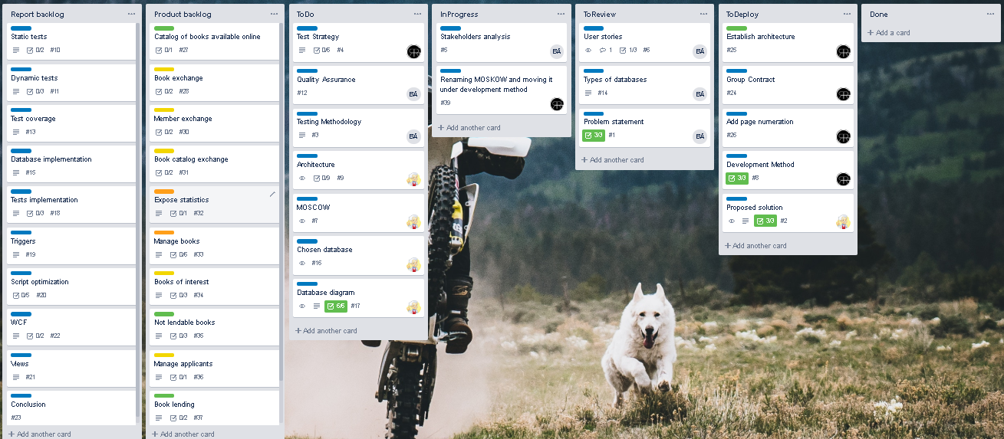

Figure

**MoSCoW:** Short for must, should, could, will not do. It is a task evaluation method used for categorizing the importance of a given task.

We used MoSCoW in the form of coloured badges representing the priority:

1. Green - must

2. Yellow - should

3. Orange - could

4. Red – will not

**Task separation:** To make the backlog easier to navigate we decided to not use MoSCoW for document-oriented tasks, instead using blue colour to identify them, as it was decided that all the planned writing tasks were to be implemented.

**Descriptions:** Each task had a separate section where a more detailed description complimented the title to remind other members on the team what the task was about and what were the intended results.

**Comments:** Knowing that communication is key when it comes to working in groups, it was important to quickly and reliably provide feedback on the state of the task, this was done by the utilization of comments, which allowed us to comment on the quality of the final implementation and possibly even reject it entirely, but still provide adequate feedback without actually contacting the member.

**Check list:** When a complex task is presented which might include the need of having multiple parameters or sections which must be met, a checklist is used to visually inform other users of what has or has not been implemented yet. A percentage is automatically shown on the task to indicate the finished progress.